1 Overview and Goals

  - Project Overview
The scenario chosen for this project is Scenario 2 – Local Marketplace / Classifieds. This application is meant to be a local online marketplace where people from the same community can advertise items they want to sell, find items they want to buy or exchange products with other users.
The application's main content is made up of listings posted by users. Each listing contains a title, description, price, category, listing type, condition, location, seller information, creation date, and an image. These listings can be browsed on the main marketplace page, with users able to click thru to an individual listing for more detailed information.
This application also has an inquiry system in which users communicate with each other. If a user is interested in a listing, he can open the detail page and send a message to the seller. Members can bookmark listings to their favorites, while users can also flag listings that may be inappropriate for moderation review.
This project is completely implemented on the front end using HTML, CSS, JavaScript and jQuery. JavaScript objects hold the initial application data and browser localStorage is used to store changes like new or edited listings. So the application demonstrates the required functionality without using a real server-side application or database, as allowed by the project specification.

1.2 Problem Statement

There is often a need for the local community to advertise their products and/or services, or things they are willing to exchange. The Marketplace application becomes a convenient interface to create and view such listings. It allows users to easily go through all of the available listings using various filters without page reloads. More details about particular listings are provided on separate pages.
User-generated content management is another issue to be solved. It is important that users are allowed to add and edit their own listings but not other listings by other people. Besides, there should be a way of reporting inappropriate listings. That is why the application has different user roles and moderation processes.

  - Intended Users
Local Marketplace is designed to assist individuals residing within a campus or the local community, looking for an easy means of buying, selling, or swapping of goods. Common users might include members of the campus such as students, and residents of the local community seeking to either sell unwanted products, locate inexpensive second-hand goods, look for specific products, or swap products with other users.
The application is tailored to facilitate the interactions of not only those that only wish to view the marketplace content but also those that are active participants by posting their products or communicating with the sellers. This also takes into account the requirement for the moderation of content generated by users on the platform.
For this reason, the application specifies three user roles: Visitor, Member, and Moderator. The specific permissions and requirements related to these roles are outlined in the Requirements Gathering section.

  - Project Goals
The primary purpose of the project is to design a minimal yet functional marketplace front-end application by using the concepts of web development, security, requirements analysis and software architecture introduced during the course.
In particular, the project should accomplish the following tasks:
- create a user-friendly interface for navigating the listings in the local marketplace;
- facilitate dynamic searching and filtering of the listings without reloading the whole page;
- provide full CRUD support for the Listing entity;
- store marketplace-related data in browser localStorage;
- enable members to add and manipulate their listings;
- create listing detail pages and provide an inquiry mechanism for communicating with sellers;
- enable members to keep track of their favorite listings;
- offer a reporting procedure and an interface for moderating the flagged content;
- create role-based functionality for Visitor, Member and Moderator users;
- verify form inputs and show relevant validation errors;
- render user-generated content safely in order to avoid potential XSS attacks;
- create a responsive interface which works well on various screen sizes; and
- structure HTML, CSS, JavaScript code and data in a convenient way.

2.Requirements Gathering

Requirement gathering is done to know what the system needs to provide, the stakeholders that would be interacting with it, and the quality requirements of the application. In the case of the Local Marketplace application, requirement gathering was done by selecting a particular scenario along with the three user roles involved: Visitor, Member, and Moderator.
This process includes both functional and quality aspects of the application.

2.1 Stakeholders and Their Needs
The stakeholders of the Local Marketplace application are the Visitors, Members, Moderators, and the local community itself. Every stakeholder has its own requirements for the system.

Visitor
Visitors are users who primarily visit the marketplace and may communicate with sellers without creating any listings.
The primary requirements of visitors are as follows:
- browse all existing listings,
- search listings by keyword,
- filter listings by category, listing type, and price,
- open listing and read all information about it,
- communicate with the seller through the inquiry form,
- work with the application without the opportunity to modify marketplace content.

Member
Members are those users who are active participants in the marketplace since they not only browse but also create and manage listings in the marketplace.
Their requirements are as follows:
- access to all browsing capabilities offered to visitors,
- creation of new listings in the marketplace,
- editing of their own listings when there is any change in the listing details,
- deletion of their own listings when there is no further need for them,
- ability to add interesting listings in their favorites,
- ability to remove listings from their favorites,
- sending inquiries to sellers regarding other listings,
- viewing of inquiries received for their own listings,
- ignoring of unnecessary inquiries.

Moderator
The moderators need to review the reports submitted by the users on the marketplace.
Some of their requirements include:
- Accessing the moderator’s dashboard,
- Viewing reported listings,
- Reviewing the details regarding the reported listing; and,
- Removing the reported listings that are not appropriate,
- Ignoring the report if the listing is not needed to be removed.

2.2 User Stories
A user story is a description of application's features in terms of a person using it. The below is the list of user stories sorted out according to three roles identified in Local Marketplace scenario.
Visitor User Stories
US-V1: As a visitor, I would like to browse through listings in order to be aware of the items which are being offered or requested in the marketplace.
US-V2: As a visitor, I would like to find particular items by entering keywords in order to simplify my search process.
US-V3: As a visitor, I would like to sort out listings by their categories, listing type and price in order to be more accurate with the search results.
US-V4: As a visitor, I would like to view particular listing in order to get detailed information about the item.
US-V5: As a visitor, I would like to make inquiries to sellers in order to discuss a certain listing.
US-V6: As a visitor, I should not be able to create or manage listings as posting listings in the marketplace is available for the members only.

Member User Stories
US-M1: As a member, I want to create a listing in order to advertise the product that I want to sell, buy or exchange.
US-M2: As a member, I want to edit my own listings in order to update or correct the data of listings.
US-M3: As a member, I want to delete my own listings in order to remove unnecessary advertisements.
US-M4: As a member, I want to add listings to my favorites in order to save them for future use.
US-M5: As a member, I want to remove listings from my favorites in case of losing interest in the products.
US-M6: As a member, I want to send inquiries concerning other listings in order to contact sellers of the products.
US-M7: As a member, I want to view received inquiries concerning my own listings in order to learn about users' interest in the products.
US-M8: As a member, I want to dismiss received inquiries in order to get rid of unnecessary inquiries.

Moderator User Stories
US-MOD1: As a moderator, I would like to see a reported listing in order to review any inappropriate content.
US-MOD2: As a moderator, I would like to delete a reported listing in order to delete inappropriate content from the marketplace
US-MOD3: As a moderator, I would like to dismiss a report in order to keep the appropriate listing accessible.

2.3 Functional Requirements
In order for the Local Marketplace application to be functional, it has to implement the core functionality related to browsing and management of the marketplace content. All users must be able to browse through the available listings, view information about specific listings individually, and search for listings based on particular keywords. The listings can be filtered by category, listing type, minimum and maximum price. Search and filtering operations update the displayed results without reloading the entire page.
The application has to offer all of the CRUD operations on its core entity, Listing. The members have to be able to create listings by filling out a validated form, view their listings both through the marketplace and their personal dashboard, edit their listings, and delete their listings. When editing a listing, the information from the existing listing will be loaded to the form so that it can be changed. The created and updated listings are stored in browser localStorage. The application should also allow communication between users and sellers. Via the listing detail page, visitors and members may send an inquiry along with their name, email address, and the message they have. The form to send the inquiry should be validated before the submission of data. Members can view inquiries received for their own listings and dismiss those they no longer need.
Also, the marketplace should include favorites and content reporting features. Members can save listings to their favorites, see their favorites listings, and delete them from favorites. The listings may also be reported by the users for further moderator consideration. Reported listings will be seen in the moderator dashboard, and he may either delete the listing or dismiss the report.
Lastly, the interface should adapt to the user role selected. Creating and managing listings features should be accessible to members only, and moderation features – to moderators only. Application data and actions of users related to it should be stored in localStorage to have persistent data between page refreshes.

2.4 Non-Functional Requirements
It is also important for the interface to be consistent throughout the entire application. Such components as navigation, forms, buttons, listing cards, filters, and dashboards should have similar visual appearance and design in order to let users easily perceive and operate with the application. Forms should contain suitable labels and input fields, and the interaction with interactive elements should be possible via browser and keyboard operations.
The other requirement for the interface is its responsiveness and the mobile-first approach. It means that the interface should be scalable from mobile screens to tablets and desktops. This feature is implemented using CSS Grid, Flexbox, and media queries in order to change the placement of such components as navigation, filters, and listing cards.
As for performance-related considerations, interactions that involve search and filter should give immediate feedback without reloading the entire page. Due to the small dataset that this application processes on the client side, listings take place directly in the browser.
Security is yet another non-functional requirement due to the user-generated content used by the application for both listings and inquiries. User input should be properly validated and limited, while user-generated text should be properly rendered to prevent any Cross-Site Scripting (XSS) vulnerabilities. However, due to the fact that this is a client-only application, client-side validation will not be as effective as server-side validation would be. Hence, the latter should be provided along with the former.
Maintainability of the application can be ensured through separation of the four main components of any web application – structure, presentation, data, and application logic. Structure is described in HTML files, visual presentation and responsive layout are defined using CSS, and data and page-specific behavior are processed using JavaScript files. Function and variable names are meaningful.

2.5 Use Cases
Below are the two use cases that represent the interactions in the Local Marketplace application. The first one is about creating content in the marketplace by a member, and the other is about the report and moderation process.
Use Case 1 : Create a New Listing
Primary Actor: Member
Precondition:
The current user role is set to Member, allowing access to the Create Listing page.
Main Flow:
- The member clicks on Create Listing on the navigation menu.
- The create-listing form is shown to the user.
- The member fills in the listing title, description, price, category, listing type, condition, location, seller name, and optionally an image URL.
- The member submits the form.
- The system checks if the entered details are correct.
- If the entered details are all correct, then the system creates a new Listing object.
- The new listing is then added to the existing listings and saved in localStorage.
- The user receives a success message.
- The user is then redirected to the dashboard page where the newly created listing is shown in the "My Listings" section.

Alternate Flow:
If some of the details entered by the user are incorrect, then a listing will not be created. The system will show an inline error message for the incorrect field, and the user can then enter the correct information and resubmit the form.
Postcondition:
A valid new listing is now stored in localStorage and available in the marketplace.

Use Case 2: Report and Moderate a Listing
Primary Actors: Marketplace User and Moderator
Precondition:
A listing exists and can be accessed through its detail page.
Main Flow:
- A user accesses a listing in the marketplace.
- The listing detail page is shown to the user.
- The user clicks on the "Report Listing" button.
- The selected listing is flagged as "reported" and the updated listing is saved into the localStorage.
- When the role "Moderator" is selected, the reported listing will be shown in the moderator dashboard.
- The reported listing is reviewed by the moderator.
- The moderator decides to either "Remove Listing" or "Dismiss Report".
- When "Remove Listing" is clicked, the listing will be deleted from the marketplace data in localStorage.
- When "Dismiss Report" is clicked, the listing will be left in the marketplace and its reported status will be removed.
- Moderator dashboard is updated accordingly.

Alternative flow:
If there are no reported listings, the moderator dashboard will show a message saying that there are no reported listings to review.
Postcondition:
Either the reported listing is removed from the marketplace or the reported status is removed from the listing.

3. Architecture and Design

3.1 System Architecture
The Local Marketplace application adheres to a separation of concerns principle where the application's structure, presentation, data, and logic are separated in different files. Such an architectural design choice was made due to the fact that the application has many pages and different types of functionality such as listing management, filtering, role-based behavior, inquiry, favorite, and moderation.
The presentation layer is implemented using the HTML pages and the external CSS stylesheet file. The HTML files define the structure of different views of the application, while the stylesheet defines the visual theme and responsiveness of the application. There are four basic views in the application which are marketplace listing, listing creation/editing, listing detail view, and role-specific dashboard.
Application logic is implemented through JavaScript and jQuery. Rather than implementing all the logic in one JavaScript file, the logic is separated according to its responsibilities. For instance, the logic of the marketplace application will include rendering and filtering listings dynamically; create/edit logic will be responsible for performing form validations and handling CRUD operations; detail-page logic will include listing details, inquiries, and reporting, and the dashboard logic will implement the logic of the membership of members and moderators. Interface logic for different roles is also separately implemented.
The data layer consists of the JavaScript listing data and the browser localStorage. In order to provide initial records in the marketplace application, we have the JavaScript data source that provides the initial records of the marketplace, and we use the localStorage to keep changes performed while working with the application. The design decision to use such an architecture has been made due to the following reasons: the difference is well-established between the content being displayed by the application, its style, handling of interactions, and storage of application data. While the application itself is completely client-side, this gives rise to the architecture that resembles a separation used in a web application.

Application Structure:
Every HTML page serves a certain purpose. index.html is the main marketplace and shows the search and filterable listing grid. The form that is used to both create and edit listings is contained within create.html. details.html is the one that shows details of a listing chosen and inquiry capabilities. Finally, dashboard.html offers functionality for different roles like member's listings, favorites and inquiries, and reported listings for moderators.
Similarly to the HTML pages, JavaScript files are organized based on responsibilities. Listing data are provided in data.js, the listing page is handled in app.js, creation and editing of listings are in create.js, detail page and inquiry and reporting are in details.js, member and moderator dashboards are in dashboard.js, and the interface is controlled by roles.js.

3.2 Data Model
The data model for the Local Marketplace application revolves around two main entities, namely, Listing and Inquiry. Listing is the main entity of the application that facilitates all the CRUD operations, whereas Inquiry is the entity that enables communication between the users and listing owners. Extra information, such as favorites and the user’s role, is kept in localStorage separately from the rest of the information.

Listing Entity:
The Listing entity is the advertisement that appears in the market. The listing can be about an object that a user intends to buy, sell, or swap.
Table 3.2.1
Attribute | Description
Id
  Unique identifier of the listing
title | Title of the listing
description | Detailed information about the listing
price
  Price associated with the listing
category | Category such as Books, Electronics, Furniture, or Bikes
type
  Listing type: Sell, Buy, or Exchange
condition | Condition of the item: New or Used
image | Image associated with the listing
sellerName
  Name of the seller
ownerId | Identifies the member who owns the listing
createdAt | Creation date of the listing
reported
  Indicates whether the listing has been reported
location
  Location of the listing

Inquiry Entity:
The Inquiry entity represents a message sent regarding a particular listing
Table 3.2.2
Attribute | Description
id | Unique identifier of the inquiry
listingId | Identifies the related listing
sellerName | Name of the seller receiving the inquiry
sellerOwnerId | Identifies the owner of the related listing
senderName | Name of the person sending the inquiry
senderEmail | Email address of the sender
message
  Message sent to the seller

Relationships and Supporting Data:
The entities are linked by identifiers that are stored within the application data. A member can have several listings, with ownerId indicating the owner of the particular listing. Several inquiries can be associated with one listing, while listingId indicates the listing that the inquiry is related to. The sellerOwnerId identifier determines which member will receive an inquiry on the dashboard.
Additional data is also required for other features of the application. Listing objects are not duplicated for favorites; the listing ID is used to refer to the listings. User role is stored in localStorage, thus allowing for maintaining its role-based behavior. Listing's reported status helps to determine whether the listing will be shown in the Moderator Dashboard.

3.3 Data Storage in a Real Product
The current application stores its data in JavaScript and browser localStorage because it is implemented entirely on the front end. In a real production application, listings, inquiries, users, favorites, and moderation data would instead be stored in a server-side database and accessed through a backend application.

3.4 Wireframes, Mockups and Design Decisions
The screenshots below represent the final implementation of the major screens of the Local Marketplace Application. The interface was developed to ensure the same structure on all pages but varying functionality based on the user’s chosen role.
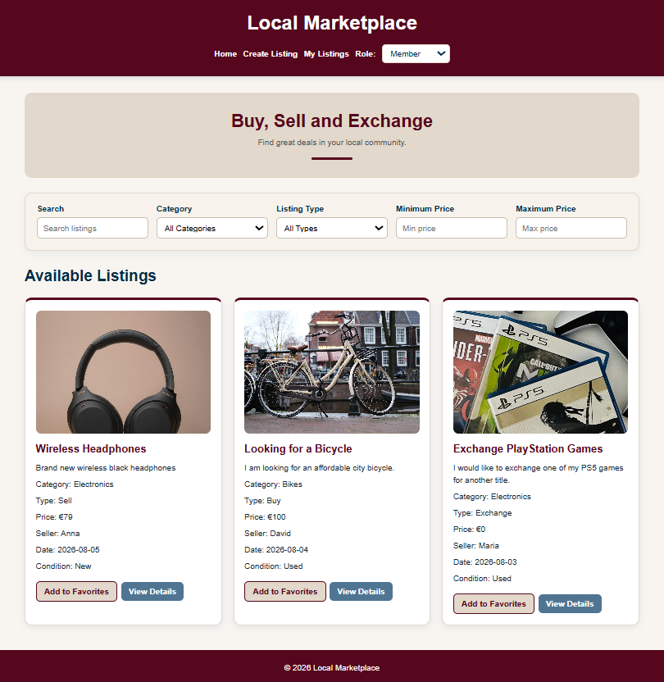
Figure 1: Main Marketplace Page
The homepage of the marketplace represents the main area of browsing for the user within the application. There are navigation bar and role selector located on the top of the page. The Search bar, Categories, Listing Type and Min/Max Price filters are located above the listings. The listings themselves are represented as cards which contain an image and the most important information about the product. The Add to Favorites and View Details buttons allow to perform actions with each listing directly from the card itself.
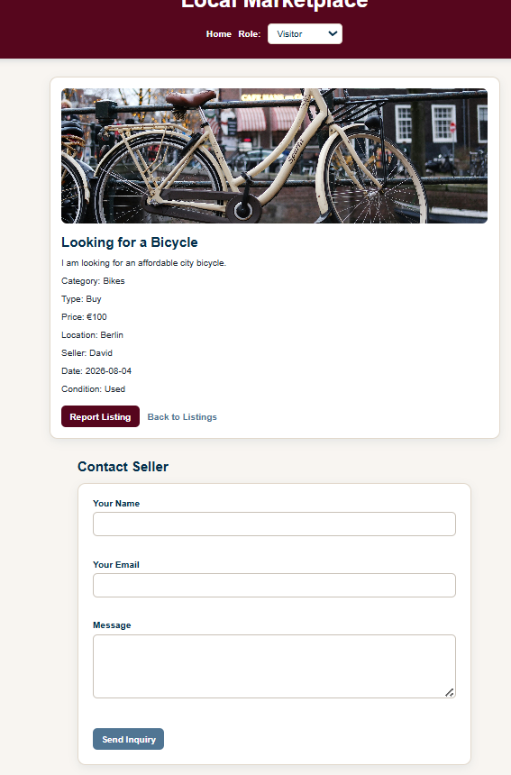
Figure 2: Listing Details Page
The page of the listing contains one particular listing, where an image of the listed item along with all the required information such as Category, Type, Price, Location, Seller, Date, and Condition is shown. An option of Reporting Listing is also there for moderation. The Contact Seller form is given below the listing information, so that a user does not have to go anywhere else to contact.

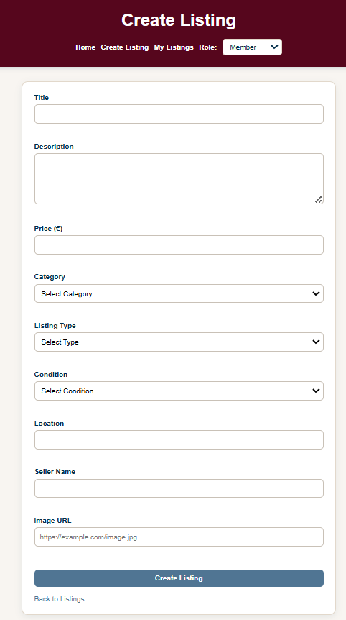
Figure 3: Create Listing Page

The create listing form has been kept very simple and easy by using a one column form structure. It consists of fields for title, description, price, category, listing type, condition, location, seller name, and image. The associated control elements are arranged in a vertical manner, and the primary submit button is placed separately at the bottom of the form.
The same form is used while editing the listing. When the listing edit functionality is selected, the form gets filled automatically with the listing details, the page title becomes Edit Listing, and the submit button gets changed to Save Changes.

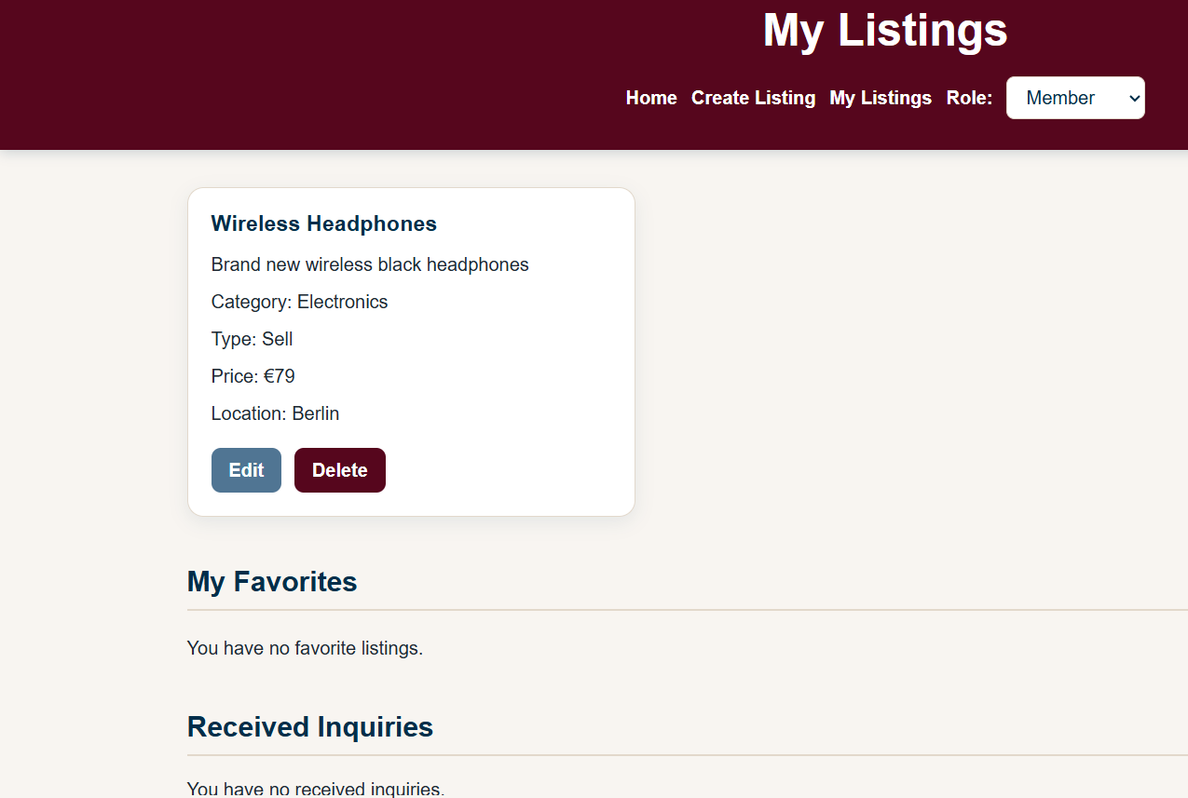
Figure 4: Member Dashboard
The Member Dashboard integrates all the features that have to do with the member currently logged in. In the My Listings section, it shows all the listings of the member with Edit and Delete options available for managing them. At the same time, there is another area on the same page called My Favorites and Received Inquiries.

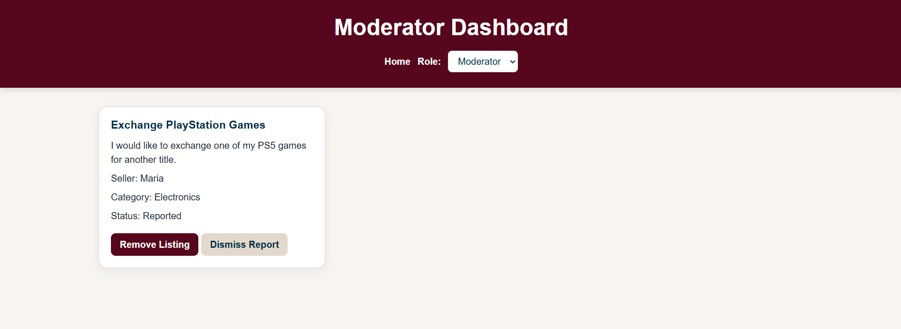
Figure 5: Moderator Dashboard

The Moderator Dashboard is the user interface specific to the moderator. This UI shows all those listings which have been reported by users. In case there are no reported listings, this UI is designed in such a way that it makes its users aware about this situation instead of showing them an empty listings section. Furthermore, the navigation has been made easy for the moderator as there is no display of member-specific options like adding listings.

3.5 Key Design Decisions
The application has an unified design style throughout all its pages. Dark burgundy color was chosen as the primary one for headers and action buttons, while light color served as the background in order to make the application easier to use. Secondary colors include dark blue, which is applied for secondary headers and actions in order to differentiate them from primary elements. Listing data is provided in card-style containers in order to distinguish separate marketplace objects.
The application has been developed in such a way that it provides convenient access to important actions. Search and filter options are located just above the list of listings on the main page, while listing-specific actions such as "Add to Favorites" and "View Details" are available in the cards of listings. Forms have a simple single-column structure in order to allow completing input fields in logical order. Another important aspect that needed to be taken into account during the design process was role-based navigation. Navigation depends on the chosen role, and so it is possible for members to have access to listing management tools, whereas moderators will have access to moderation tools. Another technique used in the layout is CSS Grid, Flexbox, and media queries.

4. Security Considerations
Security is an important consideration in the Local Marketplace application because users can enter and display content through listing and inquiry forms. Although the project is implemented entirely on the client side, several measures are used to reduce invalid input, unsafe content rendering, and unauthorized access to role-specific functionality. The main security threats considered in this project are invalid or malicious user input, Cross-Site Scripting (XSS), and unauthorized access to role-specific functionality.

4.1 Input Validation
Client-side validations have been set up for the Create/Edit Listing form as well as the Contact Seller form. Before the form can be accepted by the system, JavaScript performs a check to verify whether the entered value fits into the expected format and constraints. In case of an invalid value, the form is not processed and an error message is generated on the spot.
In case of the listing creation or edit form, the application ensures that the title has at least 3 characters, description has at least 10 characters, price is greater than or equal to zero, category, listing type and condition are selected, proper location and seller details are provided and an optional image value is checked to ensure that it is either a valid web URL or a valid local image path used by the application.
In addition to the above, in case of the contact seller form, the sender’s name has only alphabets allowed in it, email matches the email pattern and message is of at least 10 characters long with textual content.

4.2 XSS Prevention and Safe Rendering
The Cross-Site Scripting attack is especially applicable in the case of the Local Marketplace as the listing and inquiry data can include user-entered data. Malicious HTML or JavaScript code would then have a possibility to get executed by the browser when it interprets the content entered by the users.
In order to minimize such attacks, the application utilizes safe DOM manipulation where possible. This means that the user-entered data can be set for the dynamically generated elements using textContent property which does not interpret the value as the executable HTML code.
Wherever there are template strings and innerHTML used in the code, the escapeHTML() function is used on the user-generated content before setting it as innerHTML of the element.

4.3 Access Control
Each role gets different functionalities within the application. The selected role is saved in the localStorage, and this is what determines which navigation items and actions will be available within the interface.
Functionalities that are specific to members include functionalities like listing creation and functionalities related to the listing management of the member. The Create/Edit page is accessed only after checking the current role, and ownership data saved using ownerId will help in displaying and managing the listings of the member.
The moderator functionalities are kept separate from the member functionalities. If the Moderator role is selected, then the dashboard will show reported listings and allow functionalities like removal of the listing or dismissal of the report.

4.4 Limitations of Client-Side Security
The security measures employed in the current project can be deemed sufficient for a prototype front-end but definitely not enough for a live marketplace application. The fact is that data stored in localStorage can be easily accessed or changed by the user using browser developer tools, and role checks carried out using JavaScript can be altered as well because everything is happening on the client side.
In a true-to-life application, it would be necessary to authenticate, authorize, verify ownership, validate input, and store data using a trusted server. Of course, client-side validation and limitations could be used along with that, but never instead of them.

5. Implementation
Local Marketplace Application has been developed as a front-end web application which uses HTML5, CSS3, JavaScript, jQuery, and localStorage of the browser. This application has been split into several pages and JavaScript files such that each component has a well-defined responsibility. This section describes the technologies used in the development of the application, structure of the implementation, main functional requirements that have been met, and the major challenges faced.

5.1 Technologies Used
HTML5 technology was used for defining the structure and the content of the application pages. Semantic tags were used for organizing the structure of the interface. Such semantic tags include header, nav, main, section, and footer.
The visual and responsive design of the application was created using CSS3 technology. The application interface uses a unified style of colors and styling for all the sections of the marketplace, forms, detail page, and dashboards. The content is organized by CSS Grid and Flexbox technologies, and the layout is responsive using media queries. It has a mobile first
design strategy; therefore, it starts with the single-column layout and moves to the multiple columns layout for bigger screens.
JavaScript is the one which takes care of all the application logics. This includes dynamically rendering the listings, data search and filtering, form validation, creation, and modification of Listing objects, deletion of listings, favorite handling, inquiries management, reporting of listings, and management of the dashboard.
jQuery is used for certain events and interactions with DOM elements. This is especially needed for the process of submission of inquiries form and showing visual feedback with the help of fadeIn() function upon successful submission of the inquiry. This way the project demonstrates the usage of jQuery along with JavaScript.
Browser localStorage is used for providing local storage. This includes listings, favorites, inquiries, role selection, and temporary listing identifiers, when needed. This way the changes performed while using the application are saved even after page reload without any back-end or database.

5.2 Organization of the Implementation
Implementation is done separately for the HTML, CSS, JavaScript, and image files. The system includes pages for browsing the listings, viewing details of the listings, making or editing listings, as well as for role-specific dashboard actions.
Separation of the JavaScript code based on page responsibility is also implemented. The initial data for the marketplace is separated from the scripts which are responsible for the main marketplace, create/edit function, listing details, dashboard actions, and role-related activities. This will prevent putting all the application logic in one single big script.
One common external style sheet is used throughout the application to ensure consistency of the common visual aspects like color, button styles, form elements, listing card, navigation, and responsiveness.

5.3 Implementation of Functional Requirements
The functional requirements specified in Section 2.3 have been realized through the core functionalities of the Local Marketplace application.
Listing browsing and rendering: The functional requirement for browsing marketplace listings has been realized by dynamically rendering the Listing objects in the main marketplace page. On startup, listing information is obtained either from localStorage in case there is any stored information or else using the initial JavaScript dataset. The listing cards are then rendered using this information, rather than having individual hard-coded listing cards in the HTML file.
Searching and Filtering: The need to allow searching of appropriate listings was addressed by implementing a client-side search and filtering feature. It allows searching and filtering of the listings based on their category, type, minimum and maximum prices. Once the value in one of the filter criteria has changed, the current listing collection is filtered and the resulting matches are re-rendered without reloading the whole page.
Creating, Editing and Deleting a Listing.: The necessity to enable members to manage their listings was fulfilled by providing complete CRUD operations for the Listing entity. A member is able to create a listing via listing form, view listing details, update existing listing and delete the listing. The listing form is used to both create and edit a listing with values filled automatically if in edit mode. Created, updated, and deleted listing data is persisted in localStorage so that the changes remain available after a page reload.
Listing details and inquiries: Viewing all listing details was facilitated through the Listing Details page where the listing in question is identified and all its information is displayed dynamically. This page also has a Contact Seller feature allowing the user to send his/her query. The valid inquiries are stored in localStorage along with the relevant listing and listing owner.
Favorites:The requirement for the members to be able to save their favorite listings has been facilitated through the Add to Favorites option. The IDs of favorite listings are saved locally to fetch the respective listings and to display them on the My Favorites section of the Member Dashboard. Members can also remove listings from their favorites when they no longer wish to save them
Reporting and Moderation: The reporting feature was added through the Report Listing action in the Listing Details page. Once the listing is reported, its reported state is changed accordingly. The reported listing will be listed in the Moderator Dashboard, from which the moderator can choose either to delete the listing or dismiss the report.
Role-based functionality: The requirement to provide different Visitor, Member, and Moderator roles was added by using the current role selected saved in localStorage. Visitors will have access to basic marketplace functionality, while members will get extra listing-related and dashboard functionality. Moderators will have their own interface for managing listings and reports.
5.4 Challenges and Solutions
One problem that we faced during development was keeping consistency of data between the initial JavaScript dataset and localStorage. As the localStorage keeps previously saved data, any modification of the initial dataset would not result in changes of listings in the localStorage if the previous version of those listings was already kept in localStorage. This problem was solved by studying the process of initialization and clearing/updating data in the localStorage if the initial dataset had been intentionally modified.
Another problem related to the need of distinguishing between creating and editing a listing, but using one form for performing those actions without duplicating the form. The solution was based on temporary storage of the listing's id in order to find the listing and insert its data into the form when it opens in edit mode. Once the update process is finished, the edit id is deleted and further opening of the form will result in creating a new listing.
Also, handling inquiries necessitated the inclusion of a method to make sure that the message would come up only for the relevant listing owner. Therefore, each inquiry is assigned the identifier of the listing and the listing’s owner. The dashboard uses the identifier of the owner of the current member to filter the saved inquiries such that only inquiries that relate to listings from the current member can be seen in the Received Inquiries tab.
Lastly, the user-generated content had to be carefully managed because some of the content in the application is generated dynamically. Therefore, input validation was used along with DOM safe insertion and HTML escaping.

6. Conclusion and Future Work
In the course of working on the Local Marketplace project, we managed to create a functioning front-end web application for the activities typical of a local buying, selling, and exchanging website. These features include browsing, searching, filtering listings, listing detail page, communication with the seller via inquiries. Members can additionally manage creation, editing, and deletion of their own listings, favorites management, and reviewing of their incoming inquiries. The project also included the feature of reporting and handling of the potentially inappropriate listings.
As the project is developed in a front-end prototype manner, certain characteristics of the actual marketplace are simulated. User roles are selected using a front-end role selector instead of any kind of authentication, and application data is saved to the browser itself and not to the server-side database that could be accessed by multiple parties. Thus, the role-based behavior can show how certain users might use the system, but it does not provide any kind of authentication or authorization.
While creating the Local Marketplace project, we had the opportunity to apply numerous web development and software architecture ideas in practice. We could see how vital it is to separate HTML markup, CSS styles, application data, and JavaScript interactions in order to keep our multi-page application neat and manageable. Moreover, during the process of development of the project, we got some hands-on experience with dynamic DOM manipulation, forms validation, CRUD operations, interface for different roles, responsive design, jQuery, and browser localStorage.
The current implementation meets all the criteria of a front-end prototype. However, there are certain areas for improvement that may be addressed in the further development of the project. First of all, the implementation could be modified to use backend servers and databases, instead of the localStorage feature of browsers. That would give the possibility to exchange the data between different browsers. Moreover, instead of the role selector, the current implementation could use a real authentication service to create user accounts and sessions.
Also, in the future, it would be nice to develop the marketplace in more detail. For instance, the inquiries could become the whole messaging system. The users could have personal profiles, and the process of moderation could include reporting reasons and some additional data. Also, it would be great if users could add images to the listing via uploading them. Thus, the current prototype of a front-end would become much more realistic.

